SCHOOL OF COMPUTER SCIENCE AND ARTIFICIAL INTELLIGENCE |  |  |  |  | DEPARTMENT OF COMPUTER SCIENCE ENGINEERING
ProgramName:B. Tech |  |  |  | Assignment Type: Lab |  |  | AcademicYear:2025-2026
CourseCoordinatorName |  |  |  | Venkataramana Veeramsetty
Instructor(s)Name |  |  |  | 1. Dr. Mohammed Ali Shaik  2. Dr. T Sampath Kumar  3. Mr. S Naresh Kumar  4. Dr. V. Rajesh  5. Dr. Brij Kishore  6. Dr Pramoda Patro  7. Dr. Venkataramana  8. Dr. Ravi Chander  9. Dr. Jagjeeth Singh
CourseCode |  |  | 24CS002PC215 | CourseTitle |  | AI Assisted Coding
Year/Sem |  |  | II/I | Regulation |  | R24
Date and Day  of Assignment |  |  |  | Time(s)
Duration |  |  | 2 Hours | Applicableto  Batches
AssignmentNumber:3.3(Present assignment number)/24(Total number of assignments)
 | Q.No. | Question |  |  |  |  |  | ExpectedTime  to complete
 | 1 | Lab 3: Prompt Engineering – Improving Prompts and Context Management  Lab Objectives:  - To understand how prompt structure and wording influence AI-generated code.  - To explore how context (like comments and function names) helps AI generate relevant output.  - To evaluate the quality and accuracy of code based on prompt clarity.  - To develop effective prompting strategies for AI-assisted programming.  Lab Outcomes (LOs):  After completing this lab, students will be able to:  - Generate Python code using Google Gemini in Google Colab.  - Analyze the effectiveness of code explanations and suggestions by Gemini.  - Set up and use Cursor AI for AI-powered coding assistance.  - Evaluate and refactor code using Cursor AI features.  - Compare AI tool behavior and code quality across different platforms.  Task Description#1  - Try 3 different prompts to generate a factorial function.  Expected Output#1  - Comparison of AI-generated code styles  Prompt 1: write a python function to find factorial  Code & output:  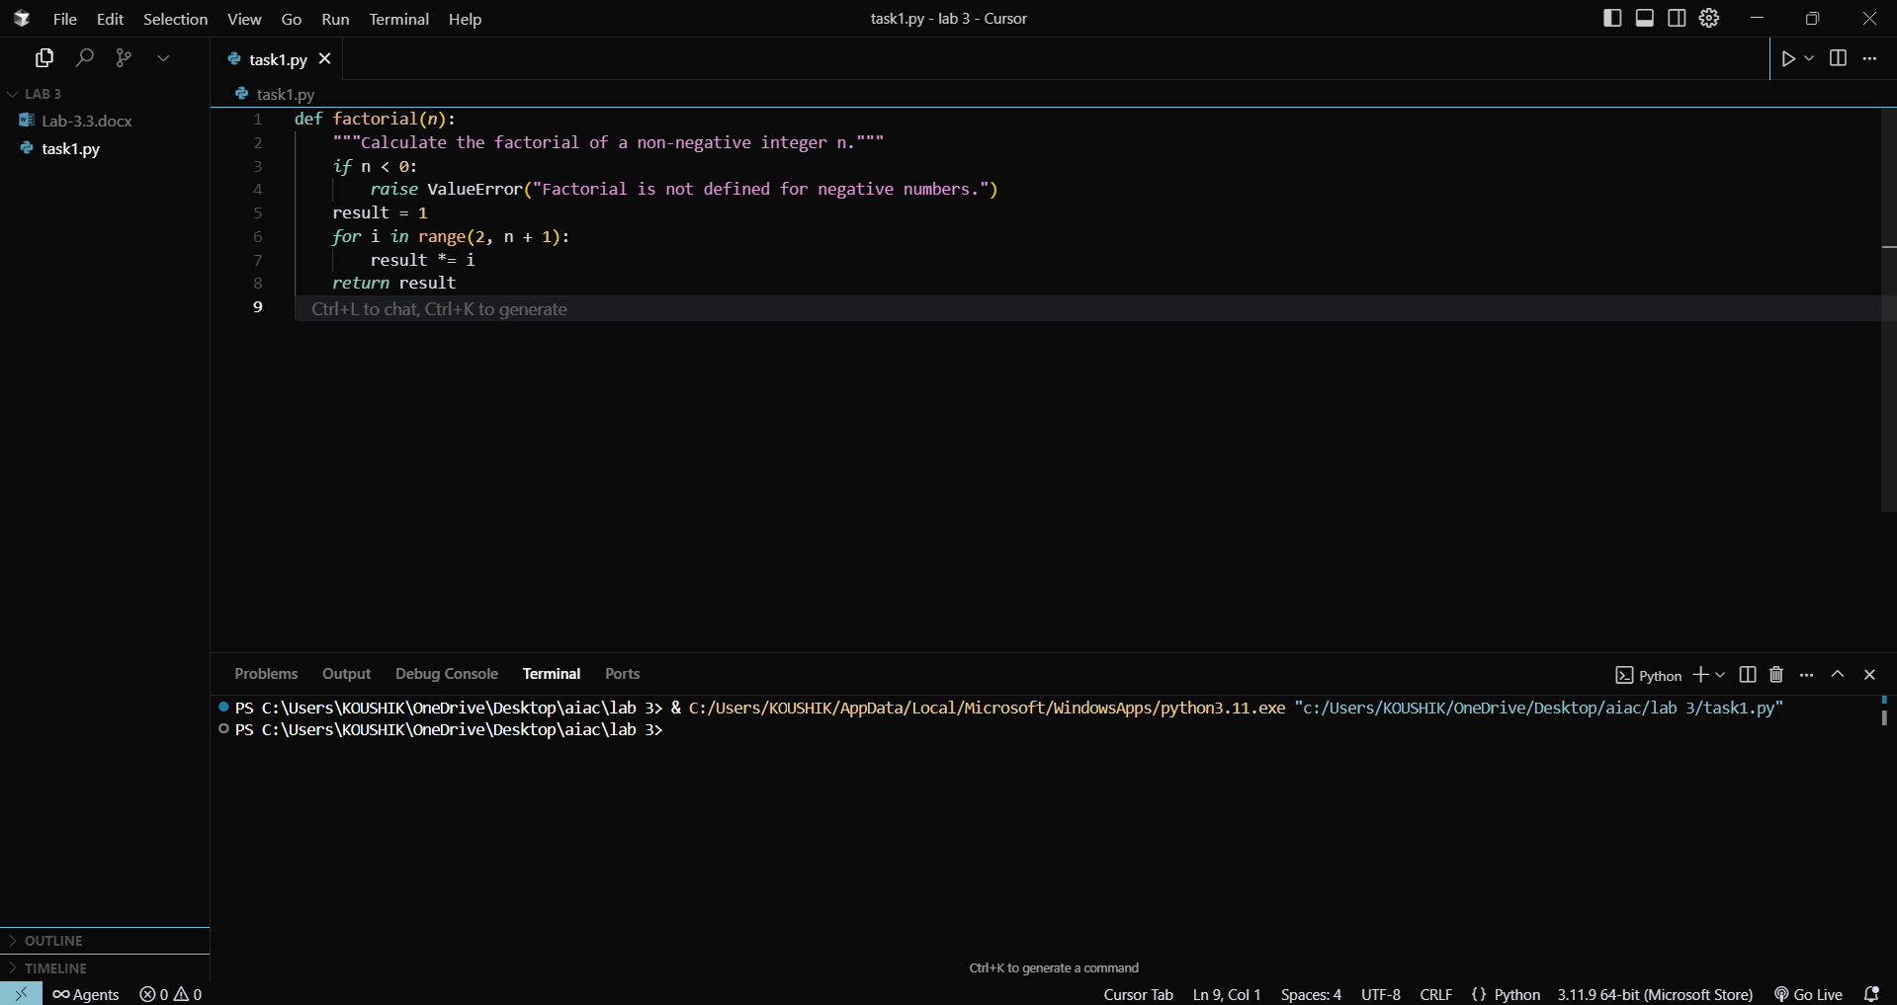  Prompt 2: write an python function that takes input from the user and finds the factorial  Code & output:  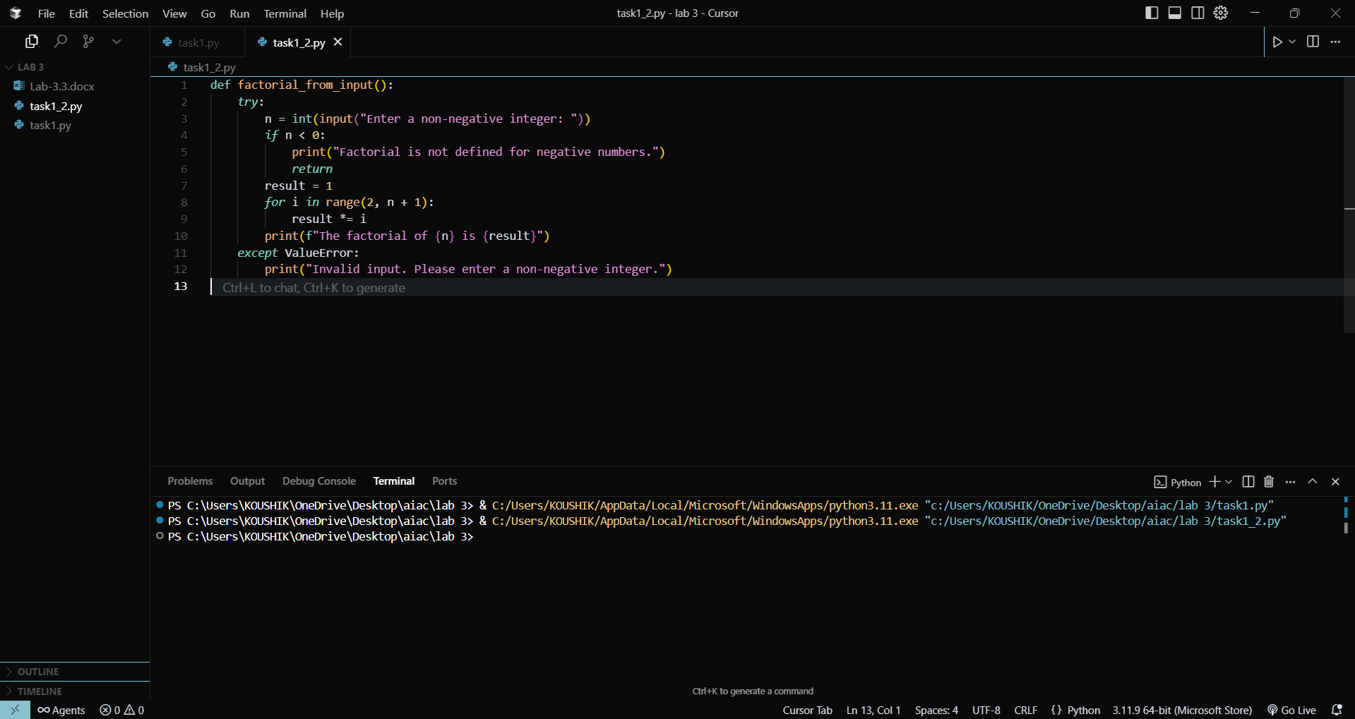  Prompt 3: write an python function that takes input from the user and finds the factorial and returns the output and calls the function to print the output  Code & output:  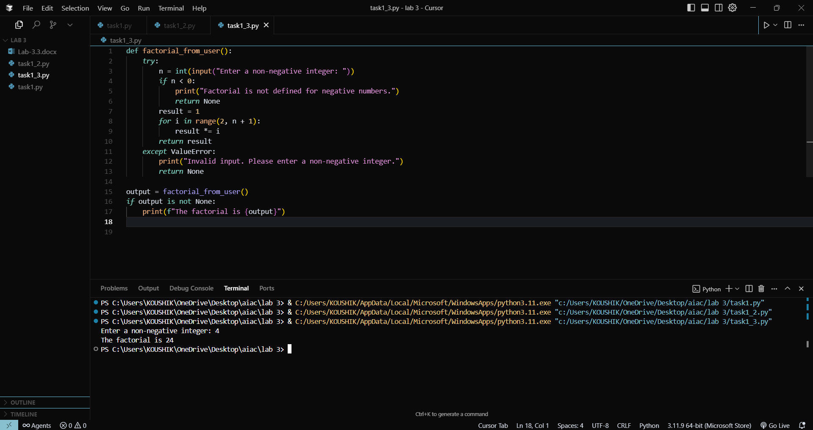  Report:  Prompt 1: it writes a function that finds factorial and returns it but doesn’t call the function  Prompt 2: it writes a function that prints the output in function itself’s  Prompt 3: it returns the value and calls the function and prints the output  Task Description#2  - Provide a clear example input-output prompt to generate a sorting function.  Expected Output#2  - Functional sorting code from AI  Prompt :write a python function that can sort an list of elements while the input is given by the user and the function should be called to print the output  Code & output:  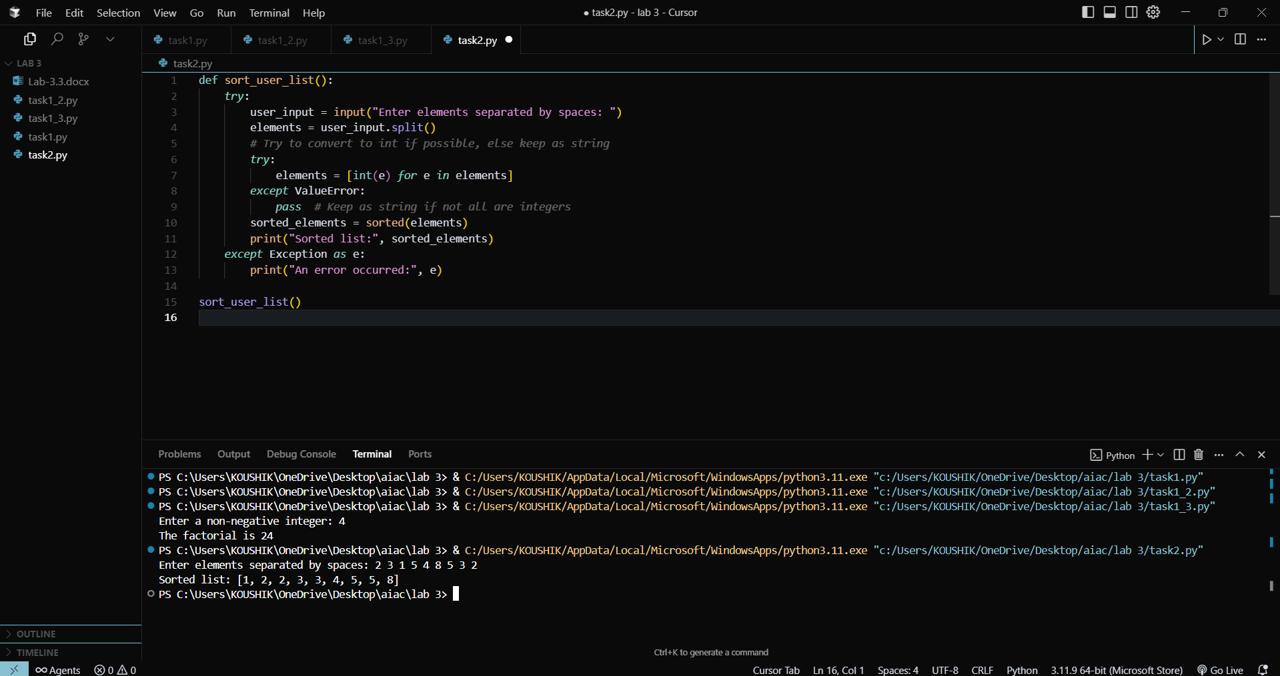  Task Description#3  - Start with the vague prompt “Generate python code to calculate power bill” and improve it step-by-step  Expected Output#3  - Enhanced AI output with clearer prompts  Prompt : Generate python code to calculate power bill  Code 1:  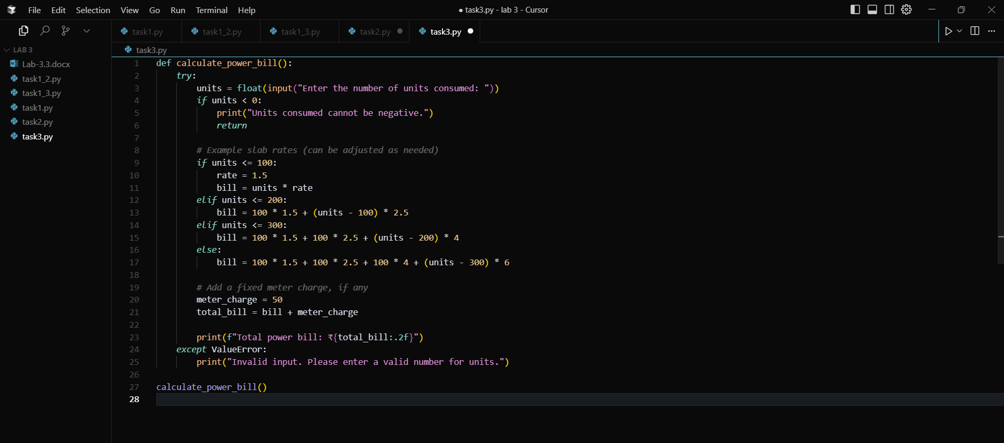  Improve 1: Generate python code to calculate power bill and make it so that the untits cost different for costomer so ask costomer type  Code 2:  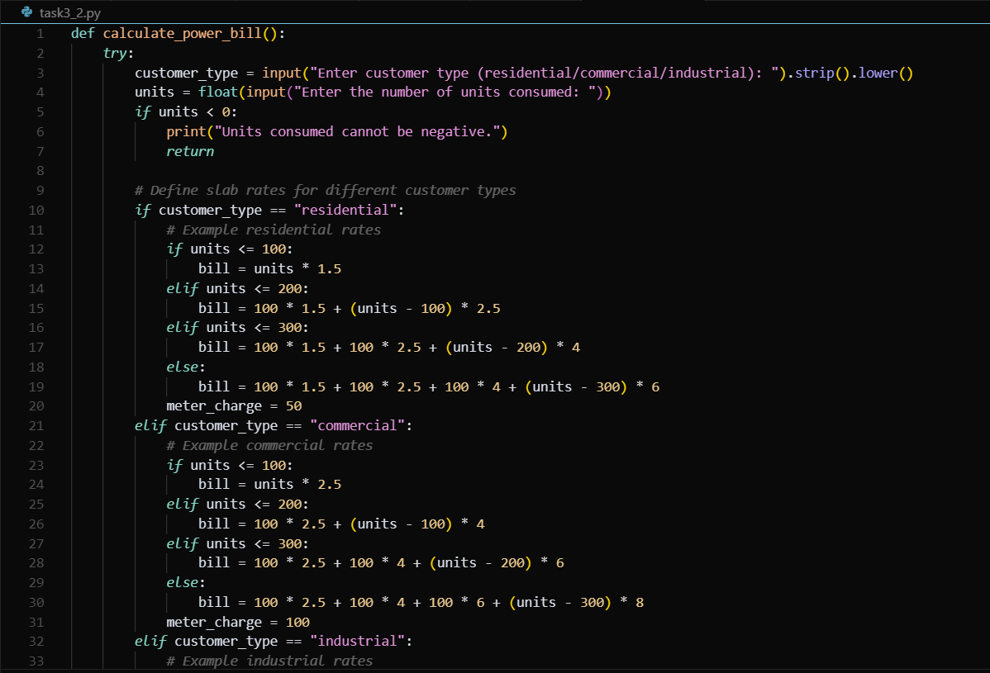  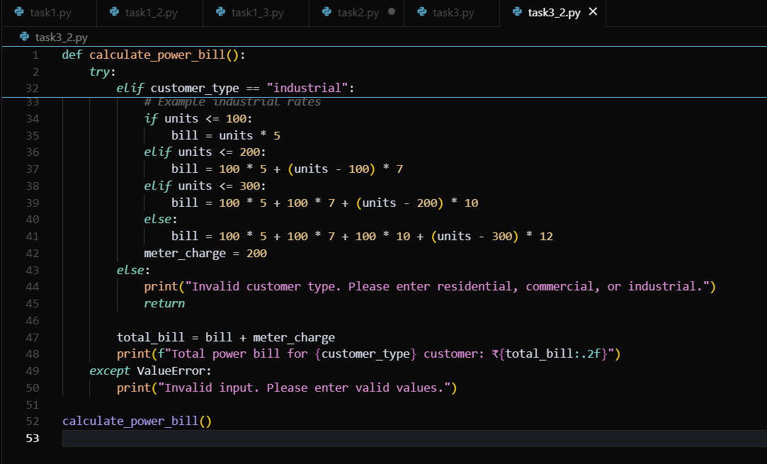  Output:  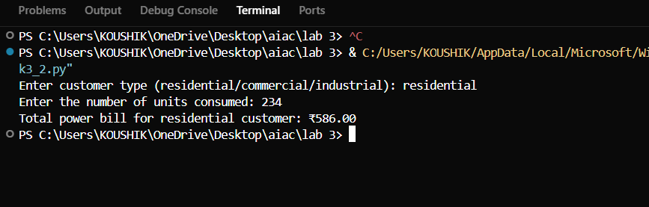  Report:  Code 1: it give the same cost to all the users.  Code 2: it asks for customer type and gives the cost.  Task Description#4  - Write structured comments to help AI generate two linked functions (e.g., login_user() and register_user()).  Expected Output#4  - Consistent functions with shared logic  Prompt: write python functions login_user() and register_user() and link those two function so user can register and login  Code:  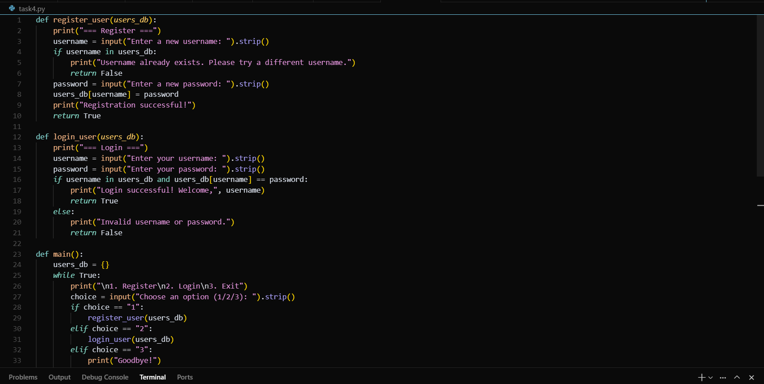  Output:  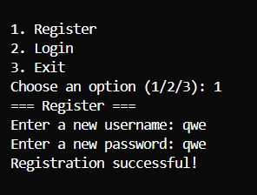  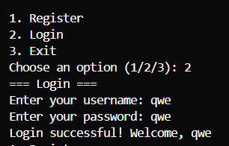  Task Description#5  - Analyzing Prompt Specificity: Improving Temperature Conversion Function with Clear Instructions  Expected Output#5  - Code quality difference analysis for various prompts  Prompt:write a python function that does Temperature Conversion by takeing in input from the user and will print the output  Code 1:  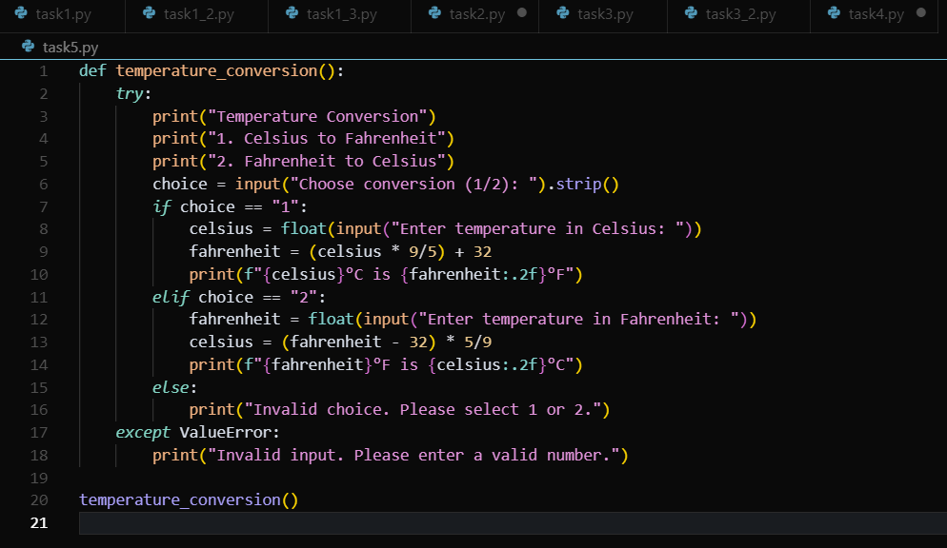  Output:  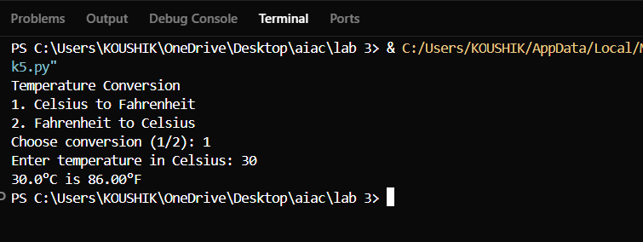  Improve : write a python function that does Temperature Conversion with all types of temperatures by takeing in input from the user and will print the output  Code 2:  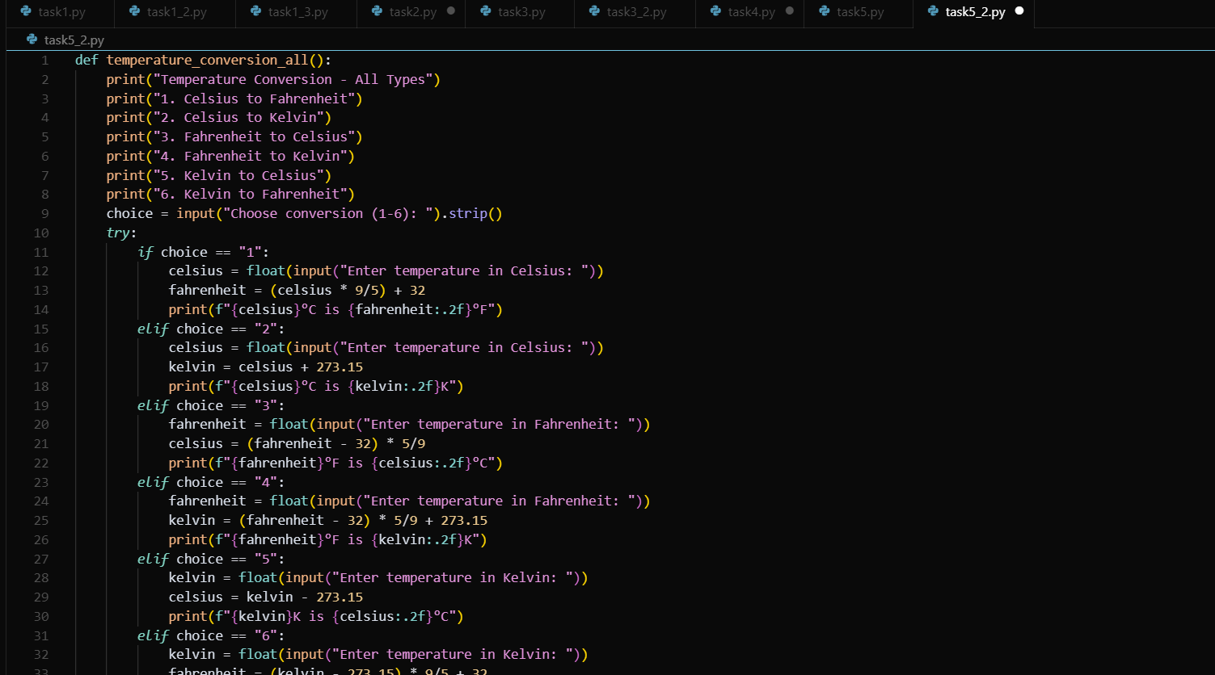  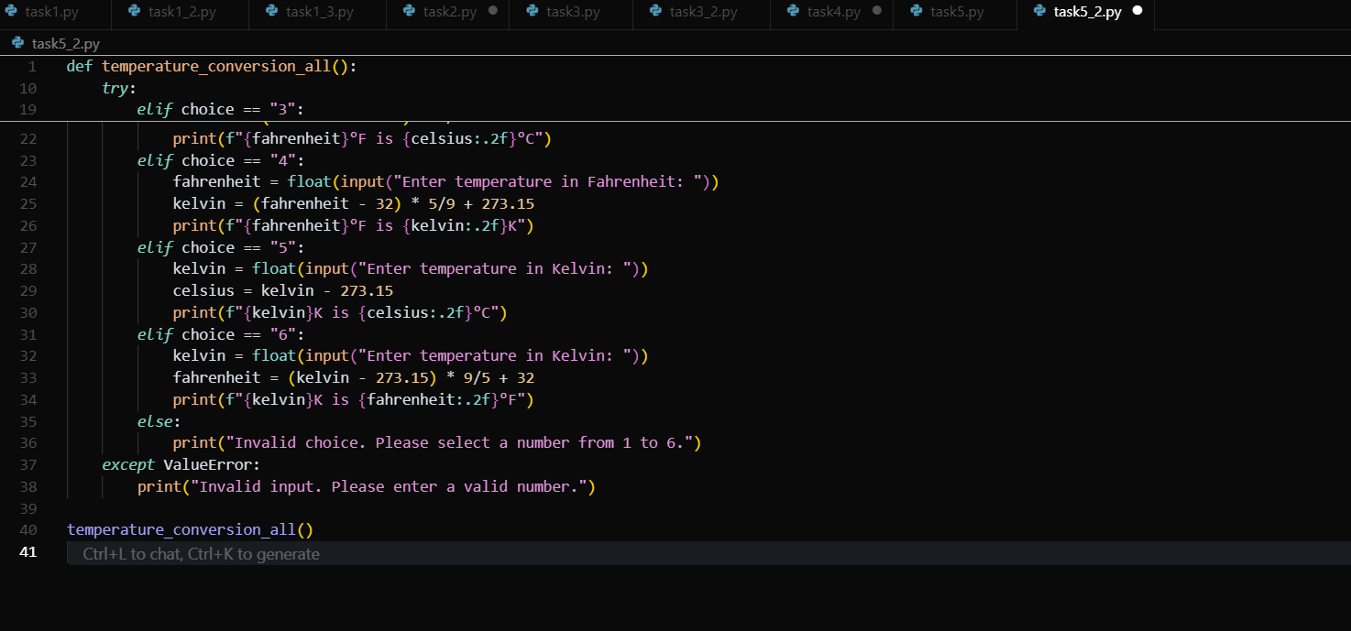  Report:  Code 1: only Celsius and Fahrenheit were given  Code 2:we can convert way more types of temperatures  Note: Report should be submitted a word document for all tasks in a single document with prompts, comments & code explanation, and output and if required, screenshots  Evaluation Criteria:  Criteria Max Marks  Factorial Function (Task#1) 0.5  Sorting Function (Task#2) 0.5  Vogue Vs. Specific Prompting (Task #3) 0.5  Linked Functions (Task #4) 0.5  Temperature Conversion Function (Task #5) 0.5  Total 2.5 Marks |  |  |  |  |  | 03.08.2025 EOD

